Bump Steer Apendix report

**Introduction**

When implementing the four-wheel steering system the suspension systems must be designed in such a way that bump steer is accounted for. The bump steer is when the vehicle wheels move on their own without input from the driver as the suspension compresses and decompresses. In order to achieve near-zero bump steer a few criteria must be met. The first is that the location of the tie rod must fall between the upper and lower control arms. Specifically an imaginary line must run through the endpoint of the upper control arms to the endpoint of the tie rod to the lower control arms. The same logic is applied to the other side of the rods as well. More importantly, the centerline of all three rods must intersect at a location known as the instant center. Both height and length are two predominant factors that dictate how pronounced the bump steer will be.

**Application**

                        The process to achieve an appropriate level of bump steer relied on both SolidWorks and Mitchel kinematics software. SolidWorks contained the master assembly suspension sketch and Mitchel would analyze the sketch and determine the bump steer by examining the toe angle. To obtain relevant results the SolidWorks coordinate system must be in line with the coordinate system. Next, the suspension system coordinates such as the upper and lower control arms are inserted into Mitchel along with other vehicle information like the wheelbase. Now on SolidWorks construction lines must be made connecting the pivot points of all the rods, and centerlines will be constructed so that all three lines intersect at the same point. With proper constraints, a SolidWorks tie-rod configuration can be achieved.

            Once the configuration is obtained coordinates of the tie rod’s inboard and hub points must be imported into Mitchel’s steering section as seen in Figure Y. After this by selecting compute Mitchel will generate the corresponding bump steer. To compile bump steer data the roll values must be held to a constant zero while adjusting the ride values (in) from -1 to 1 in increments of .25. It's important to note that achieving near-zero bump steer in the cases for this project is impractical therefore a target bump steer value should be 0.05. The proper location of the tie rod will be identified in an extensive iterative process where the inboard and outboard points are adjusted until the targeted value is reached.

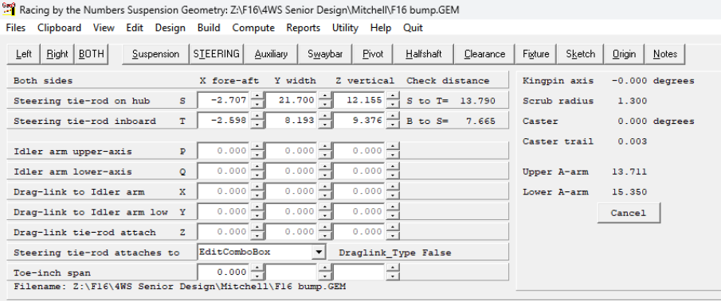

**Figure Y. Mitchel Steering Input data**

**Analysis**

While finding the point on the tie rod it was observed that the closer the rod was to the middle the smaller the bump steer values were. However, the first location that was sufficient for Mitchel had complications in SolidWorks from a packaging standpoint as the tie was too close to one of the suspension rods. Therefore, it was decided that to fix this issue the location of the inboard point will be moved further outwards in order to prevent packaging issues and maintain an appropriate level of bump steer. The Figure H below represents the adjusted configuration showing the purple tie rod inboard point being moved outwards to account for the packaging constraints.

Old Tie Rod

Upper Control Arms

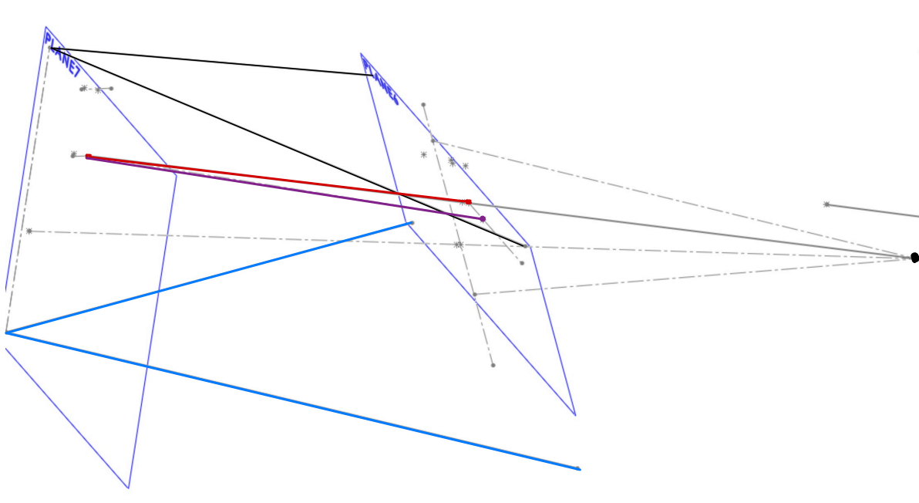

IC Point

New Tie Rod

Lower Control Arms

**Figure H. SolidWorks Adjusted Configuration Showing New and Old Tie Rod**

            In the data that was obtained seen in Figure Z there is almost a linear relationship between the toe (deg) and ride height (in). On end constraints, point -1 has a toe value of -0.028 and the opposite end has a value of 0.05. When examining a previous case study on bump steer this relationship shows the tie rod having the correct length but the wrong height. However, as stated previously the goal isn’t to achieve absolute near zero bump steer but to get it as low as possible while considering external factors such as packaging therefore even with this relationship the results are acceptable and will be used in the suspension system.

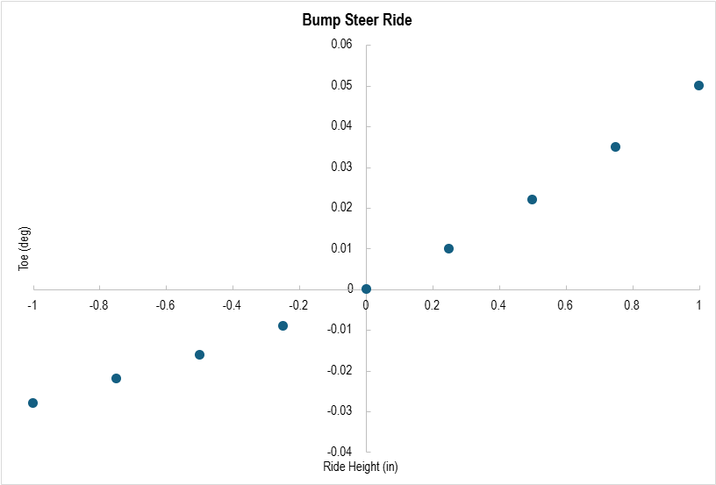

Figure Z. Bump steer Toe vs Ride Height

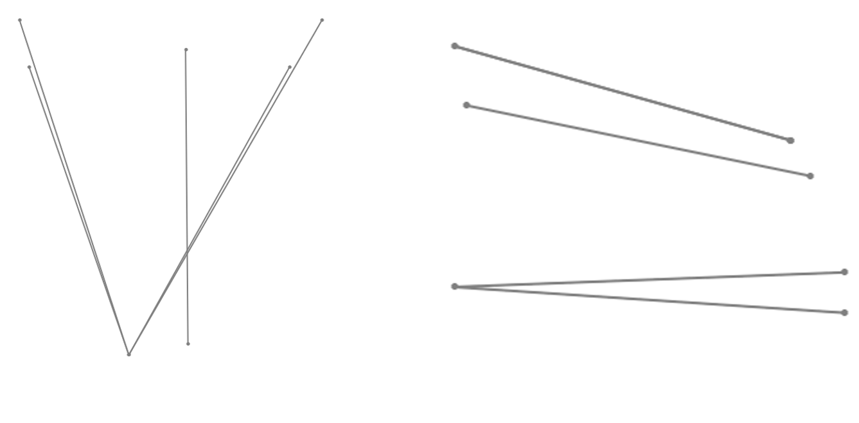Figure G. Final CAD Configuration Top and Side View